- We change the assembling type of flexible cable to display for MD-UV380 and MD-UV390 and MD-380 and MD-390 and MD-9600 and MD-2017 to solve the blank display issue
- In the VFO mode, you can set offset now
- It has 120,000 contacts now, please kindly note that before you import CSV file into radio, please check your radio version first, it should be MD-UV380(CSV) and MD-UV390(CSV-GPS)
- You can enter into menu when the signaling coming in
- Address the issue that The radio will be frozen when the main band and sub band has the same frequency but in different slots
- Address the issue that in CSV version, the display will be in chaos when press # key

Following two are for the version of 10.000 contacts only
MD-UV390(GPS-REC)-S16.06.bin (start from S) for GPS version for MD-UV380 and MD-UV390 GPS version
MD-380(REC)-D16.06.bin(start from D) for common version for MD-UV380 and MD-UV390 No GPS version

Following two are for the version of 120.000 contacts
MD-UV390(CSV-GPS)-P16.06.bin(start from P) for GPS version for MD-UV380 and MD-UV390 GPS version
MD-380(CSV)-VD16.06.bin(start from V) for common version for MD-UV380 and MD-UV390 No GPS version

Programming software version:
MD-UV390 V1.06 is for MD-UV380 and MD-390 GPS version
MD-380 V1.07 is for MD-UV380 and MD-390 no GPS version

Press side key 1 and PTT key to turn on the radio, the indicator blinks and open upgraded software

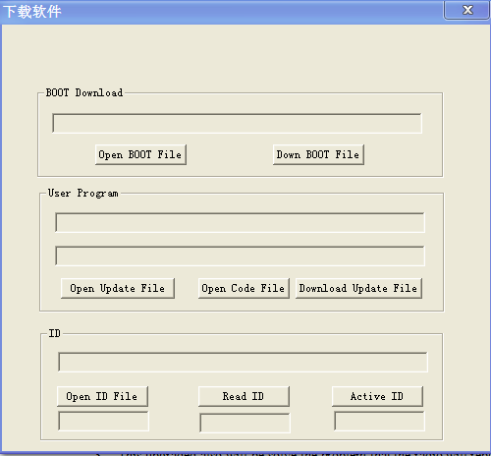

And then write upgraded file named Upgraded software for scanning function into radio, the radio will be upgraded as following:

