- Hold pressing # key and orange/blue top key, at the same time power on the radio, screen display
“WARNING This is Boot Mode for Sct!!!”

- Use the USB cable to connect radio and your PC
- Run the and install.
- Run SCT_PORT.exe
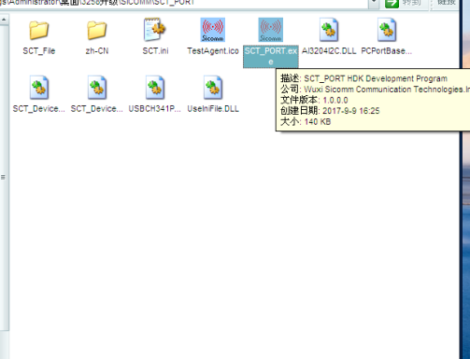
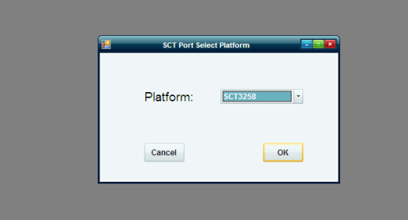
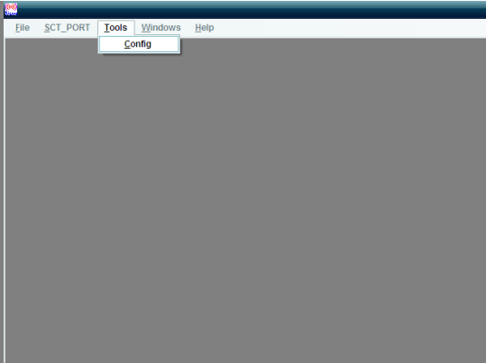
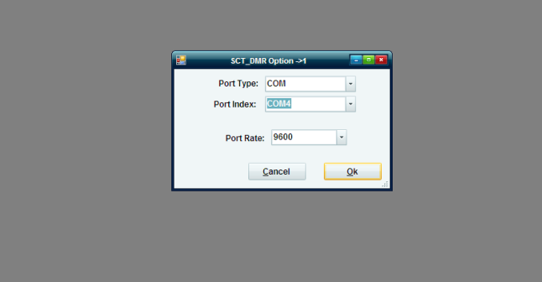
Choose the correct com port
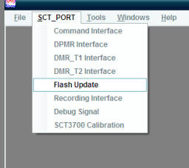
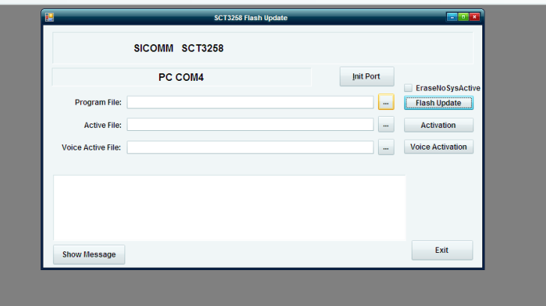
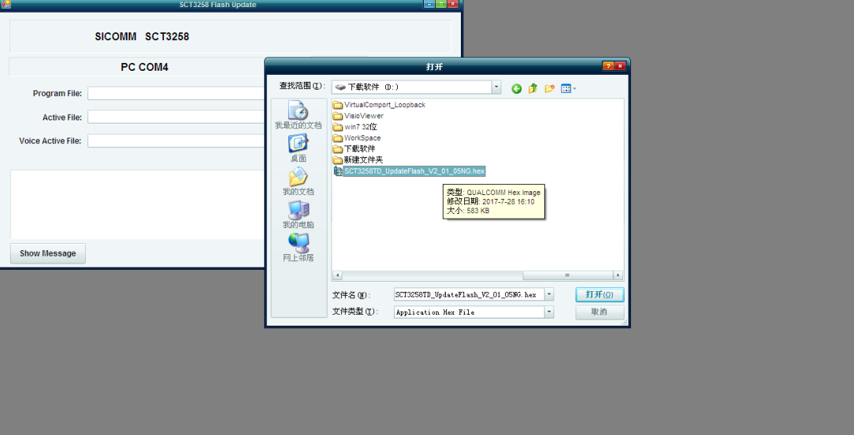
Open the .hex file
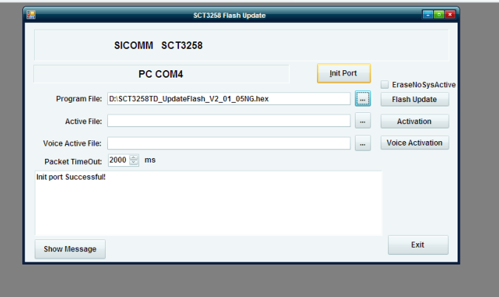
Click on “Init Port” to check the com port connection is correct
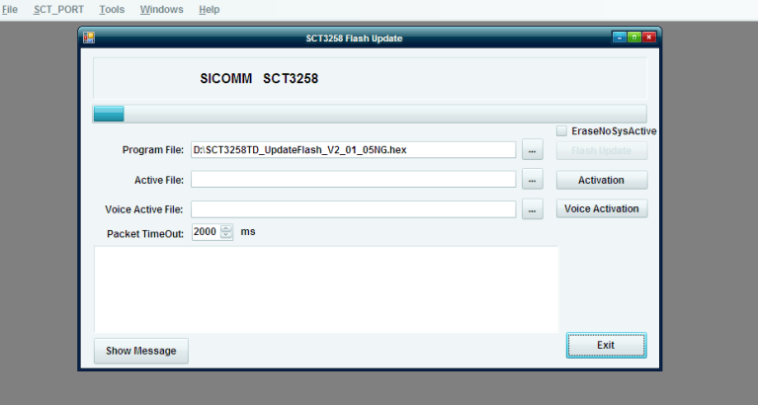
Click on “Flash Update” to start the SCT update
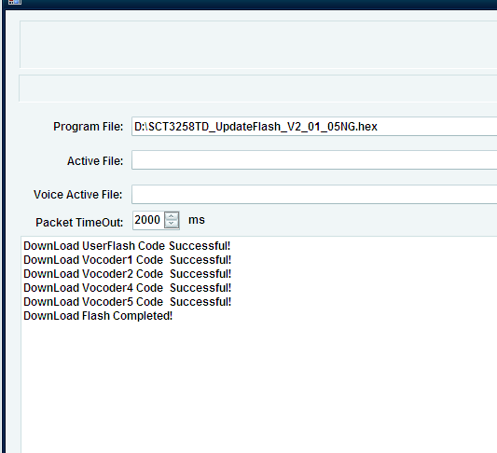
The update is done.

